Student name  Grzegorz Gliński | Multiscale modeling  Grain growth simulation | Date of submission:  11.06.2014
Specialization:  IwH | Comments: | Grade:

1. Intruduction
In this project, our task was to implement application for simulation and visualization grain growth. Three algorithms are implemented:
- cellular automata grain growth with four neighbourhood and inclusions (square or circular) before/after simulation
- modified CA grain growth algorithm – influence of grain curvature
- Monte Carlo grain growth algorithm

2. Implemented application
Application was implemented in C++ and use QT library. Common parameters for all types of simulations are:
- Space Size (eg. 100x100)
- Number of grains (eg. 10)
- Boundary type (absorbent or periodic)
- Inclusions: you can add inclusions before (in random positions) or after (on grain borders)
For simple CA grain growth implemented neighborhoods are:
- Moore
- Von Neumann
- Random Pentagonal
- Random Hexagonal
Current space state is visualized in left part of main window. Different grain IDs are represented by different colours.

3. Simulation results
Below, some graphical results obtained from application:
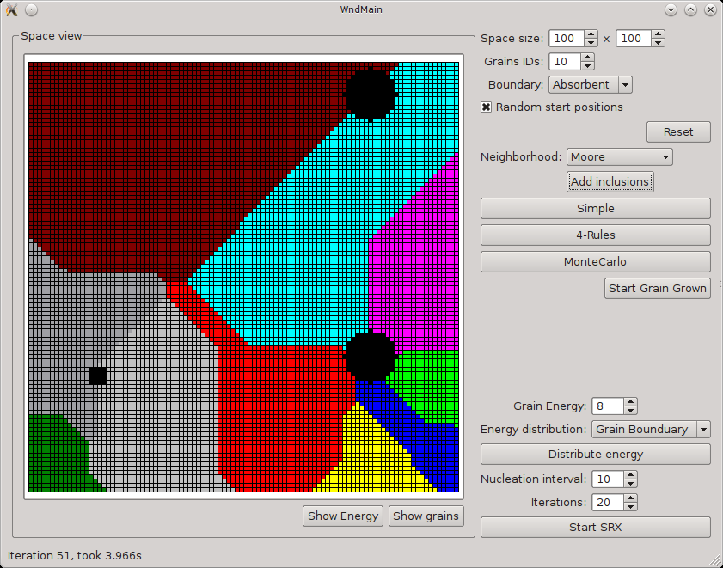cellular automata grain growth with Moore neighborhood
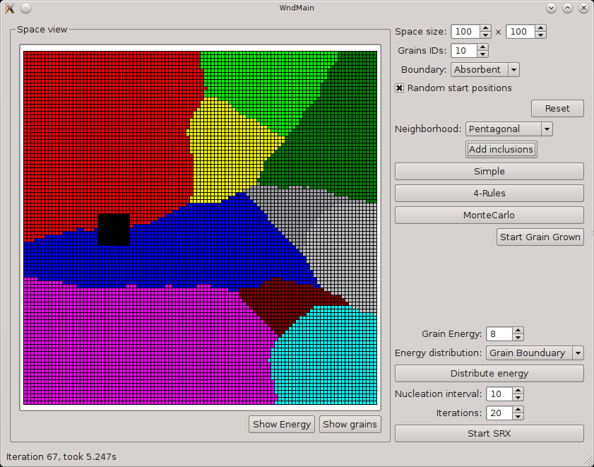cellular automata grain growth with Pentagonal neighborhood
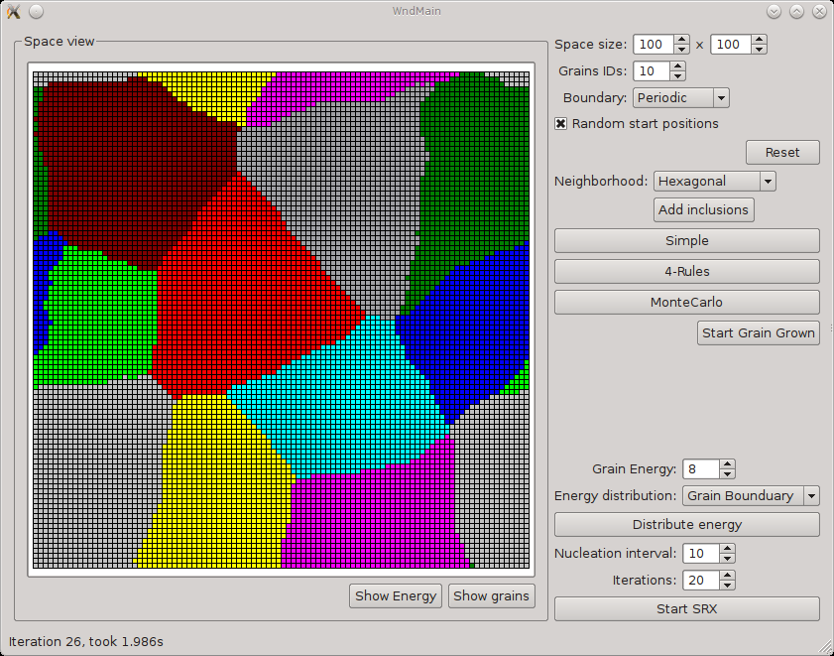cellular automata grain growth with Hexagonal neighborhood and periodic bonduary

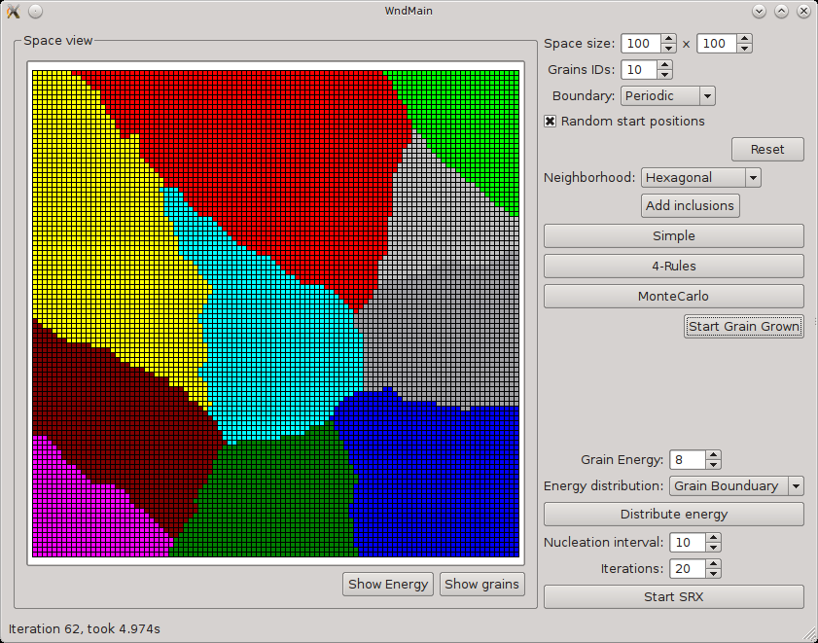modified CA grain growth algorithm – influence of grain curvature
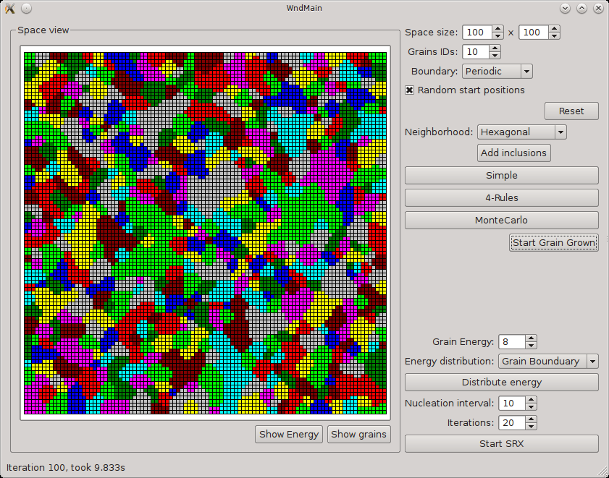Monte Carlo grain growth algorithm

